

Prograsive’s EDUCATION SOCIETY’S

**Modern College of Art, Science & Commerce ShivajiNager Pune-05.**

A

Project Report on

## Credit Based Evaluation System Submitted to

**University of Pune,**

## In the partial fulfillment of the degree of

**Master of Science (Computer Science)**

**Developed By**

**Mr.** **Bhapkar Uday Dattatray (64036).**

**Mr.Bali Pratik sanjay (64048).**

**Under the Guidance of**

**Prof. Mrs. Pawar Jigisha.**



Progressive EDUCATION SOCIETY’S

**Modern College of Arts ,Science & Commerce**

**ShivajiNager,Pune-411005**

***CERTIFICATE***

This is to certify that **Mr. Bhapkar Uday Dattatray (64036) and Mr. Bali Pratik Sanjay (64048)** as of M.Sc. (Computer Science) SEM – II has completed his Project Work(204) General Lab(215) entitled **“Credit Based Evaluation System”** as a part of curriculum, during the academic year **2015-2016.**

***University seat No:***

***University seat No:***

***Date: / /2016***

Internal External Head

Examiner Examiner Dept. Computer Science

**ACKNOWLEDGEMENT**

We are thankful to **Prof. DR.ZUNZARROA R.S.** Principal of Modern College of Arts ,Science & Commerce ,ShivajiNager, Pune-05 for making available all the required resources and co-operation in our project work.

We are thankful to **Prof. Mr.Deshmukh S.S. sir** Head of Computer Science Department, Modern College of Arts, Science & Commerce, ShivajiNager, Pune-05 for making available all the required resources and co-operation in our project work.

It gives us great pleasure to express gratitude to **Prof.** **Mrs.Pawar Jigisha.** for her valuable guidance and suggestion while preparing this project**.**

I wish to express my sincere thanks to the Principal, Head of Computer Science Department, and all teaching and non-teaching staff. For their extraordinary help throughout period of my project.

We are especially thankful to those who helped us directly-indirectly in completion of this work successfully.

**Mr. Bhapkar Uday Dattatray.**

**Mr. Bali Pratik Sanjay.**

**INDEX**

|  |  |  |
| --- | --- | --- |
| **Sr. No.** | **Name** | **Page No.** |
| **1** | **Problem Definition** | **5** |
| **2** | **Scope of System** | **6** |
| **3** | **Need of System** | **7** |
| **4** | **Proposed System** | **9** |
| **5** | **System Requirement** | **10** |
| **6** | **Fact finding Technique** | **11** |
| **7** | **Feasibility Study** | **13** |
| **8** | **Diagrams** | **16** |
| **9** | **ER-diagram** | **17** |
| **10** | **Class Diagram** | **18** |
| **11** | **Object Diagram** | **19** |
| **12** | **Use-case Diagram** | **20** |
| **13** | **Sequence diagram** | **21** |
| **14** | **Activity diagram** | **22** |
| **15** | **Collaboration diagram** | **22** |
| **16** | **Component Diagram** | **23** |
| **17** | **Deployment Diagram** | **24** |
| **18** | **Data Dictionary** | **26** |
| **19** | **Input Screens** | **32** |
| **20** | **Output Screens** | **42** |
| **21** | **Future Enhancements** | **45** |
| **22** | **Conclusion** | **46** |
| **23** | **Bibliography** | **47** |

**Problem Definition**

Many of the Universities have adapted the credit based evaluation technique . Maintaining the data to the credit based system is time consuming and tedious and is currently manual .Again it become very difficult to analyze the student’s performance subject-wise and class-wise. In the current manual system the bugs related with marks entry are difficult to recognize which may lead to false result analysis . The automated system for credit based evaluation method would make the evaluation and analysis in simple and user friendly way.

**Scope of System**

The scope of proposed system means to be Computerized Information System for details of Credit Based evaluation System. The operations done on System are maintaining records of Students credit marks points, updating students as well as marks details ,Result Analysis information like report of the student rank-wise, absent-wise, subject-wise etc.

1. Maintaining of all information at one place and in one particular format.
2. Developing the system which is cost-effective, user-friendly and convenience.
3. To speed up the manually work of the information gathering and report generation.
4. Developing the system for instant report generation for analysis

**The Scope of the Proposed system can be further discussed with the following points: -**

1. Students details: -

Managing various types of the information about Students & keep data in files so as to refer it for further operation.

2. Maintain course regarding details: -

Managing various types of the information about Department , Course, Subject &Teacher keep data in files so as to refer it for further operation.

3. Credit Marks Results Report : -

Managing various types of report of student credit marks & keep data in files so as to refer it for further operation.

4. Maintain Both Internal & External Marks : -

This system can be managed both Internal & External Marks of the students which can help to further evaluation of the student Result Analysis.

**Need of System**

The main purpose of this system is to reduce paper work and keep Students record .

Today all processing is done manually. All writing was done manually in register. Suppose record of any old Student, Student Information regarding to his marks to check then we have to need all register to check. It becomes tedious work to find manually. Due to this there are possibilities of lot of mistakes.

In this proposed system, which is computerized system records are maintain properly in a database. It is easy to retrieve record also easy to Update, Delete, Add and Insert to new records.

**Proposed System**

* The proposed system is computerized version of existing system which makes it easier to work
* System also generates various reports such as Rank-wise reports, absent-wise, Subject Marks-wise report and All Students details.
* As the system is computerized then there is less chances of error occurs and work can done with maximum speed.
* Updating of any records are easy as compared to existing system.
* Finding the records are quite simple as compared to the manual system were you had to manually search each and every record?
* Due to maximum speed the time required is less.
* Installation of any costly software’s are not required.
* Easily Printing reports and marks.

**System Requirement’s**

***Hardware and Software Used (Minimum Requirement):***

1. Hardware:-

i) Computer

ii) Hard drive : 40 GB.

iii) Ram : 1 GB.

iv) Processor : Pentium IV and above.

v) Printer : Any type of printer.

2) Software:-

i) Operating System: Linux or Microsoft Windows XP.

ii) Backend : MySQL.

iii)Frontend : JAVA(jdk 1.7).

iv) pdf Reader

**Fact Finding Technique**

* In the Credit Based Evaluation System it is very important to Result Analysis. We are preparing the project a project is based on it.
* Collection of information regarding credit System make easier to understand its procedure.

* There are several fact finding techniques namely-

1. ***Questionnaires***
2. ***Interviews***
3. ***Observation***
4. ***Record Review***
5. **Questionnaires**

We used this technique in the initial and final phase of our project. In the initial phase we prepared questionnaires to get some numerical data that was required or was missing after all the observation.

Question asked where both open ended and close ended which related to user interaction with the current system. Log records or reports generated by current system complication in the system as per the user.

1. **Interview’s**

The interview techniques help us to get the required information from the individuals of the organization by proper investigation about the process followed for the system development.

In this phase face to face question will be asked. This system is direct method of collection information speed regarding to credit based system i.e. our "Computer Science Department Modern College".

1. **Observation**

In the system we have to observe the procedure that evaluating the Credit marks point on consultant Department. How they executed there working of evaluation of the marks.

1. **Record Review**

In record review, we get the information that has been recorded in the register format.

**Feasibility Study**

A feasibility study is undertaken to determine the possibility of either improving the existing system of developing a completely new system.

It helps to obtain an overview of the problem and to get rough idea of whether a feasible solution exits this is essential to avoid committing large resources to project and then on it later.

It is necessary to evaluate the feasibility of the project at the beginning of the project. The following parameters were considered:

**1. Economical Feasibility**

**2. Operational Feasibility**

**3. Technical Feasibility**

**1. Economical Feasibility**

This feasibility study identifies the alternatives, determines the costs and expected saving of each of alternatives. This cost may include both runtime cost and recurring cost. It is observed that our system is feasible as it benefit organization in many ways.

As the system requires single computer for implementation which is approved to be quite affordable .Even the cost for training the operator is negligible, so the system was found to be economically feasible.

**2. Operational Feasibility**

This feasibility deals with the attitude and reaction of the people who will be the end user of the system, will the system be used if it is implemented and questions like these could be encountered while undertaking the above analysis. Our project is operational feasible as it provides user friendly access.

It is also called as behavioral feasibility our project. Here it was checked whether the proposed system would meet the desired requirement it was also checked how to train the end users of the system. Any computer literate can easily handle this system. Our project is operationally feasible as it provides user friendly access.

**3. Technical Feasibility**

Technical feasibility involves whether work for project can be done with the current procedures, existing software technology and available personnel.

If new technology is needed what alternative will be needed in the present structure and works echoes should be considered. This requires close approximation of the present system.

Our system is feasible because as it developed in java and the users who know computer and able to speak in English can use this system very easy.

This is concerned with analysis of the available hardware and software technologies. The implemented technology is easily available .As the system was developed using ‘Java’, and ‘MYSQL’. No extra hardware or software is required and this project is technically feasible.

**ER-Diagram**

**Class Diagram**



**Object Diagram**



**Use case Diagram**

**Sequence Diagram**



**Activity Diagram**

**Collaboration Diagram**



**Component Diagram**



**Deployment Diagram**



1. **loguser**

|  |  |  |  |
| --- | --- | --- | --- |
| Sr.No. | Field Name | Field Type | Description |
| 1. | **uname** | **Varchar(50)** | **To enter the username** |
| 2. | **password** | **Varchar(50)** | **To enter the password** |

1. **Student Info**

|  |  |  |  |
| --- | --- | --- | --- |
| Sr.No | Field Name | Field Type | Description |
| 1. | **Roll** | **Numeric(10)** | **Student Roll no** |
| 2. | **sname** | **Varchar(100)** | **Student Name** |
| 3. | **Sclass** | **Varchar(100)** | **Student Class** |
| 4. | **addr** | **Varchar(100)** | **Student Address** |
| 5. | **contact** | **Long** | **Student contact No** |
| 6. | **Email** | **Varchar(100)** | **Student email_id** |
| 7. | **DOB** | **Date** | **Date of birth** |
| 8. | **gender** | **Varchar(50)** | **Student gender** |
| 9. | **uniseat** | **Long** | **University exam code** |
| 10. | **Acadmic_yr** | **Varchar(50)** | **Academic year** |

**3) Subject Details**

|  |  |  |  |
| --- | --- | --- | --- |
| Sr.No | Field Name | Field Type | Description |
| 1. | **Sub_code** | **varchar(50)** | **Subject code** |
| 2. | **Sub_name** | **Varchar(100)** | **Subject name** |
| 3. | **Sem_no** | **Numeric(10)** | **Sem no in which subject is occur** |
| 4. | **Dept_name** | **varchar(50)** | **Name of department** |
| 5. | **Course_name** | **varchar(50)** | **Course name** |

**4) Teacher Details**

|  |  |  |  |
| --- | --- | --- | --- |
| Sr.No | Field Name | Field Type | Description |
| 1. | **Teach_id** | **varchar(50)** | **Teacher Id No** |
| 2. | **Teach_name** | **Varchar(100)** | **Name of Teacher** |
| 3. | **Dept_name** | **Varchar(100)** | **Name of Department** |
| 4. | **Contact_no** | **long** | **Contact no.** |
| 5. | **Email_id** | **Varchar(100)** | **Email of teacher** |

**5) Department Details**

|  |  |  |  |
| --- | --- | --- | --- |
| Sr.No | Field Name | Field Type | Description |
| 1. | **deptid** | **varchar(50)** | **Id of department** |
| 2. | **dname** | **Varchar(80)** | **Name of department** |
| 3. | **Contact** | **Long** | **Contact no.** |
| 4. | **HOD** | **varchar(100)** | **Name of HOD** |

**6) Course Details**

|  |  |  |  |
| --- | --- | --- | --- |
| Sr.No | Field Name | Field Type | Description |
| 1. | **deptid** | **varchar(100)** | **Id of department** |
| 2. | **dname** | **Varchar(100)** | **Name of department** |
| 3. | **Course_name** | **Varchar(100)** | **Course name** |
| 4. | **No_of_sem** | **numeric(10)** | **No_of _sem in course** |

**7) Master credit Entry**

|  |  |  |  |
| --- | --- | --- | --- |
| Sr.No | Field Name | Field Type | Description |
| 1. | **Sub_code** | **Varchar(50)** | **Subject Code** |
| 2. | **Sub_name** | **Varchar(50)** | **Name of Subject** |
| 3. | **Course_name** | **Numeric(100)** | **Course name** |
| 4. | **Semester** | **Numeric(10)** | **Sem No.** |
| 5. | **Credit_Activity** | **Numeric(10)** | **Required credit** |

**8) credit Allocation**

|  |  |  |  |
| --- | --- | --- | --- |
| Sr.No | Field Name | Field Type | Description |
| 1. | **Sub_code** | **Varchar(30)** | **To Model number** |
| 2. | **Credit No** | **Numeric(15)** | **Identification** |
| 3. | **Acitivity_ name** | **Numeric(30)** | **Battery Details** |
| 4. | **Marks_for_activity** | **Double** | **For price Details** |

**9) Internal marks entry details**

|  |  |  |  |
| --- | --- | --- | --- |
| Sr.No. | Field Name | Field Type | Description |
| 1. | **Course_name** | **Varchar(100)** | **Course name** |
| 2. | **Sem_no** | **Numeric** | **Semester no** |
| 3. | **Sub_code** | **Varchar(50)** | **Subject code** |
| 4. | **Sub_name** | **Varchar(100)** | **Subject name** |
| 5. | **Credit No** | **Numeric** | **Credit activity no** |
| 6. | **Roll no.** | **Numeric** | **Student roll no.** |
| 7. | **sname** | **Varchar(100)** | **Student name** |
| 8. | **marks** | **Numeric** | **Credit marks** |

**1) Home Screen**

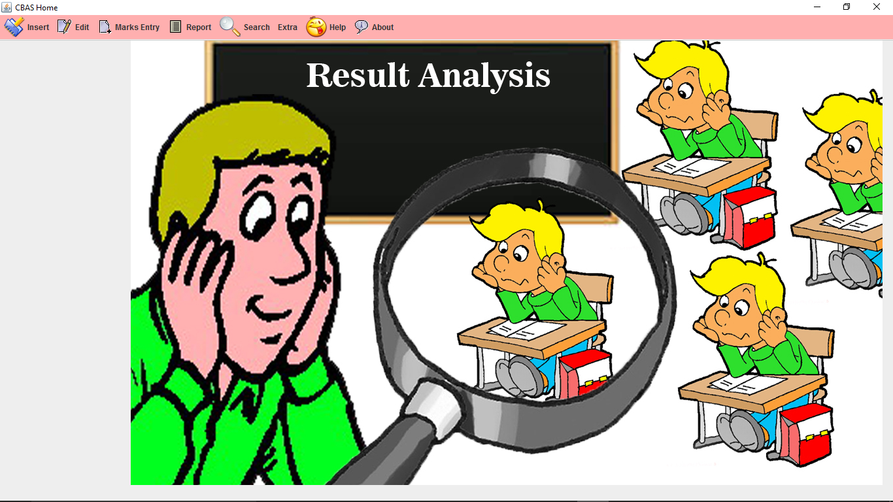

* Title window of credit based evaluation System.

**2) Login Screen**

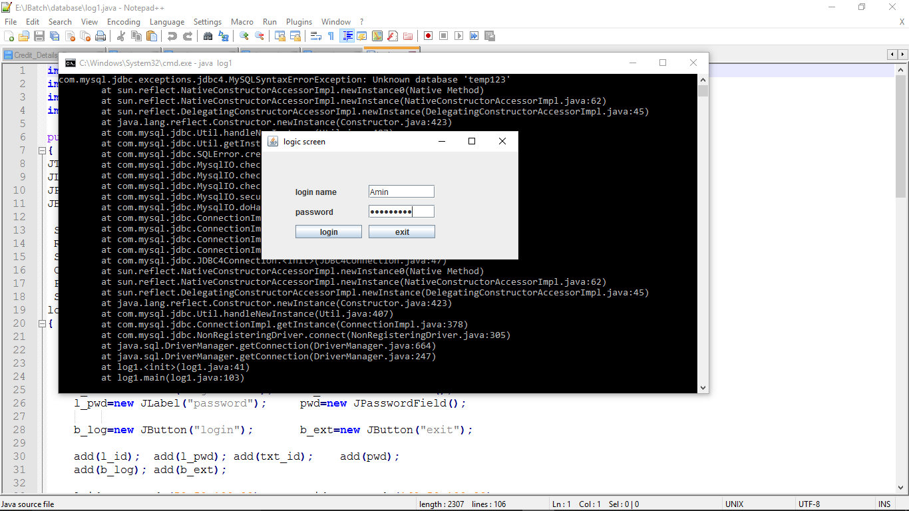

* Login window for Login into System.

**3) Menu Screen**

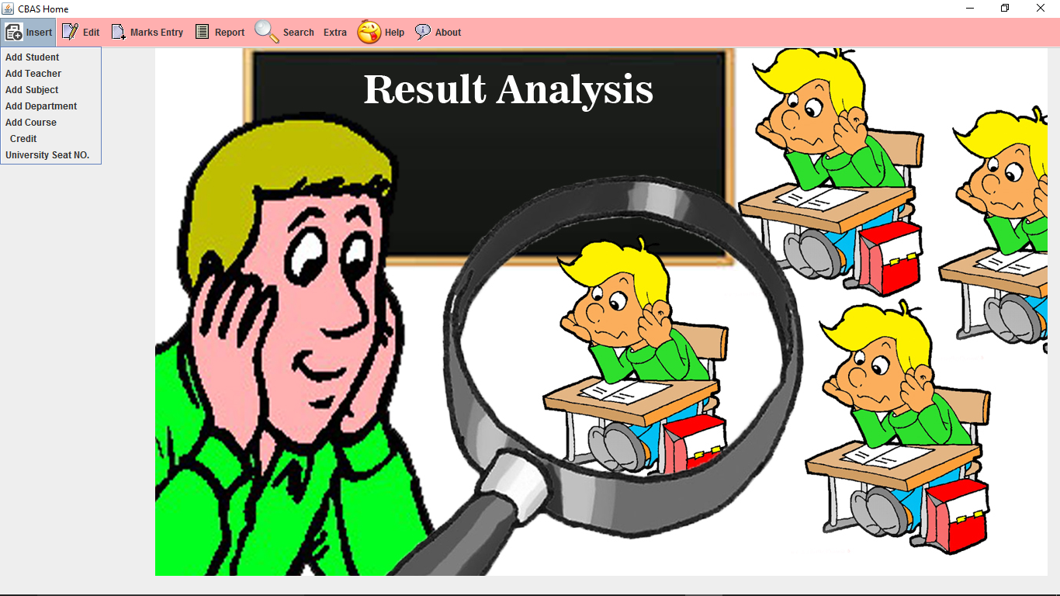

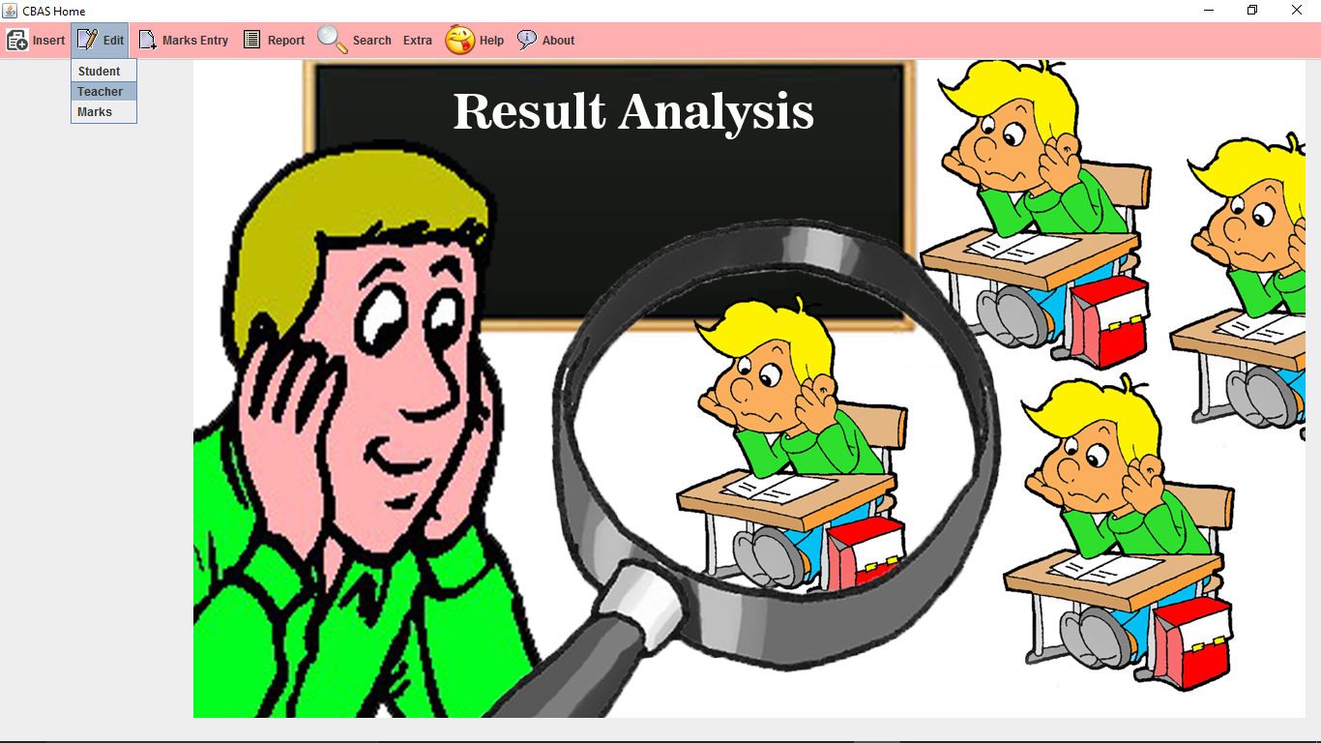

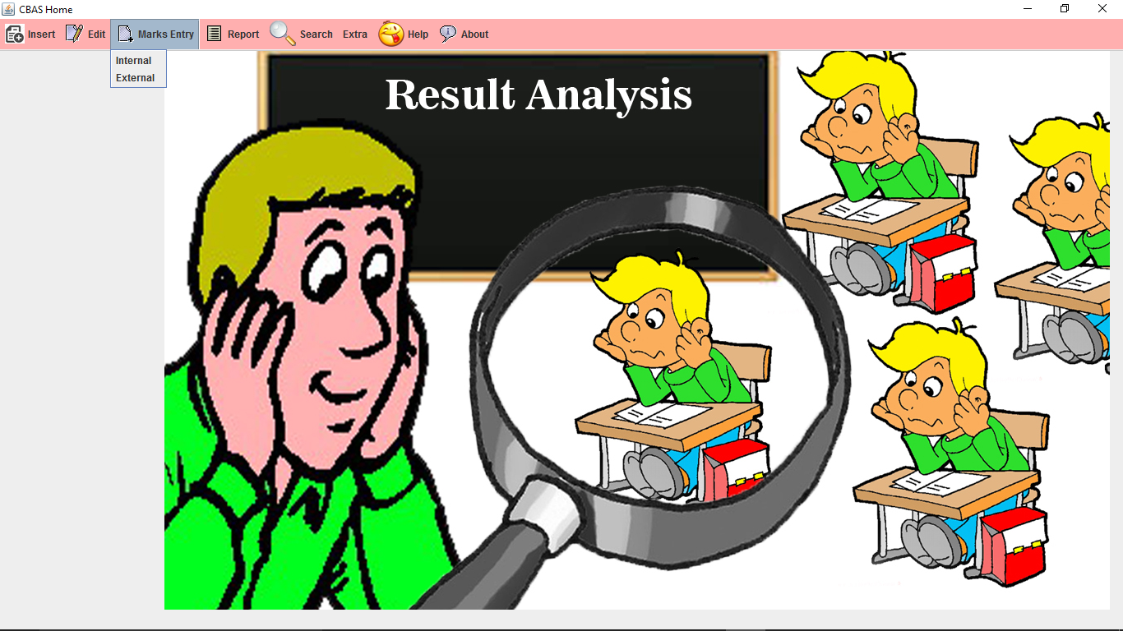

**4) Add New Student Details form**

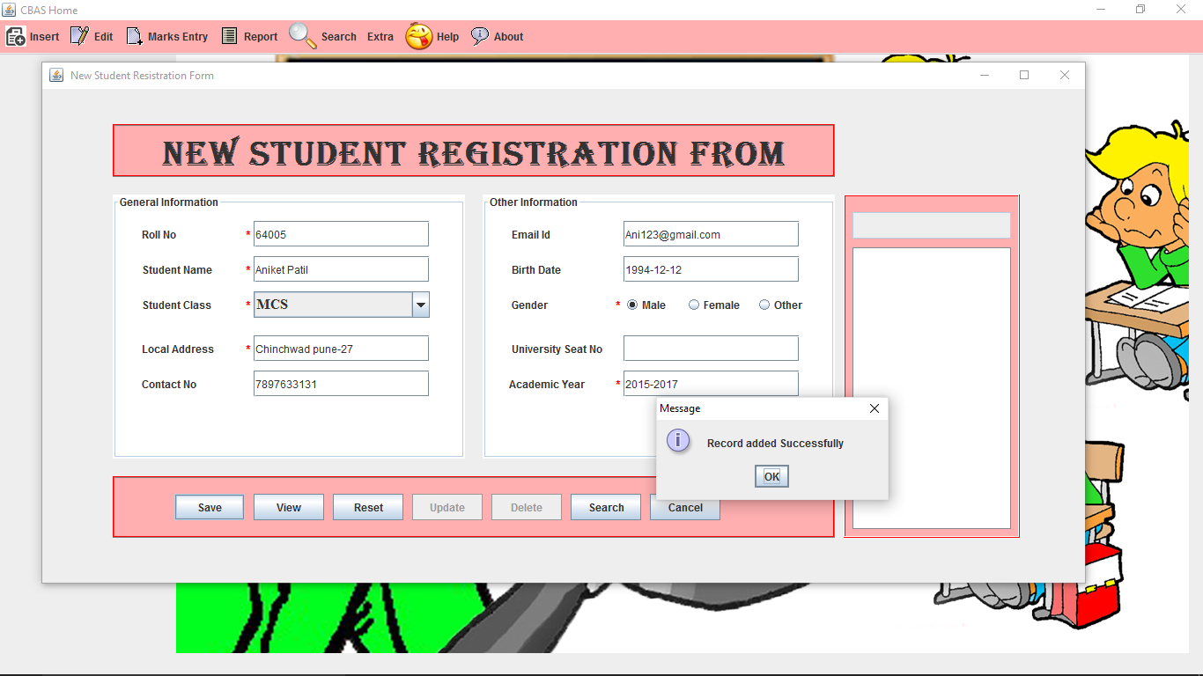

* New Student Registration Form

**4) Department Details Form**

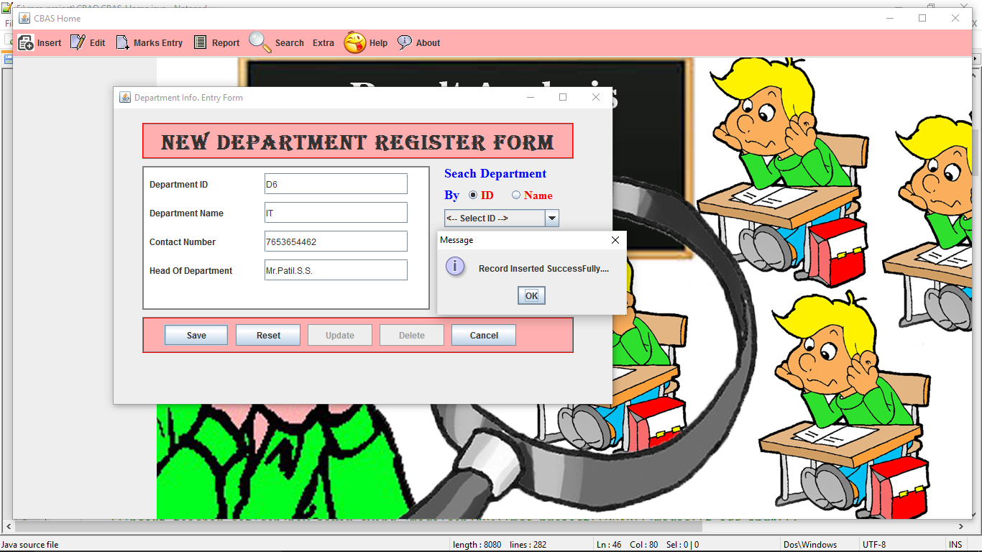

* Add New department Info.

**6)Add New Course**

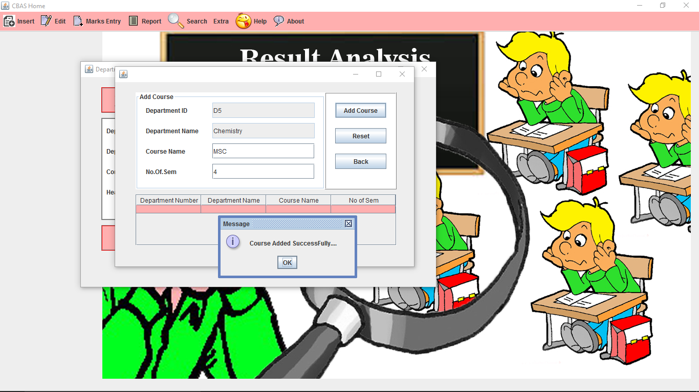

* Add the new Course Info.

**7) Add New Subject**

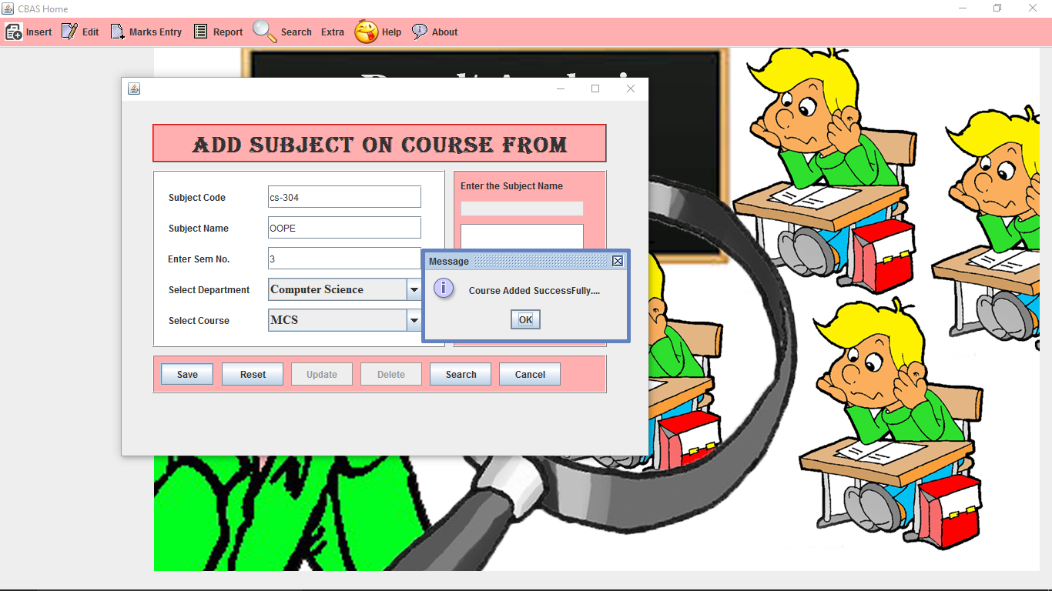

**8) Add New Teacher**

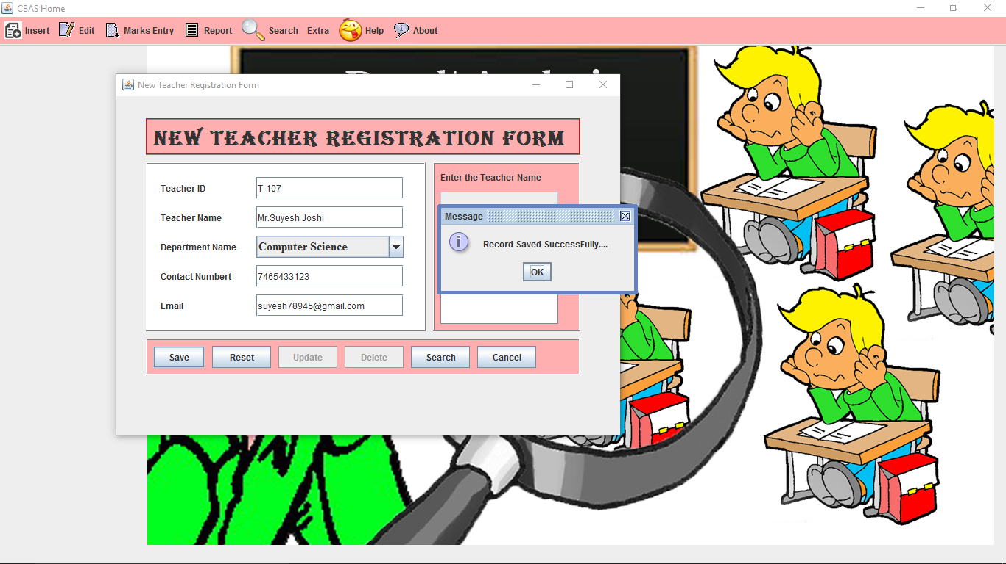

1. Entry Marks for External marks

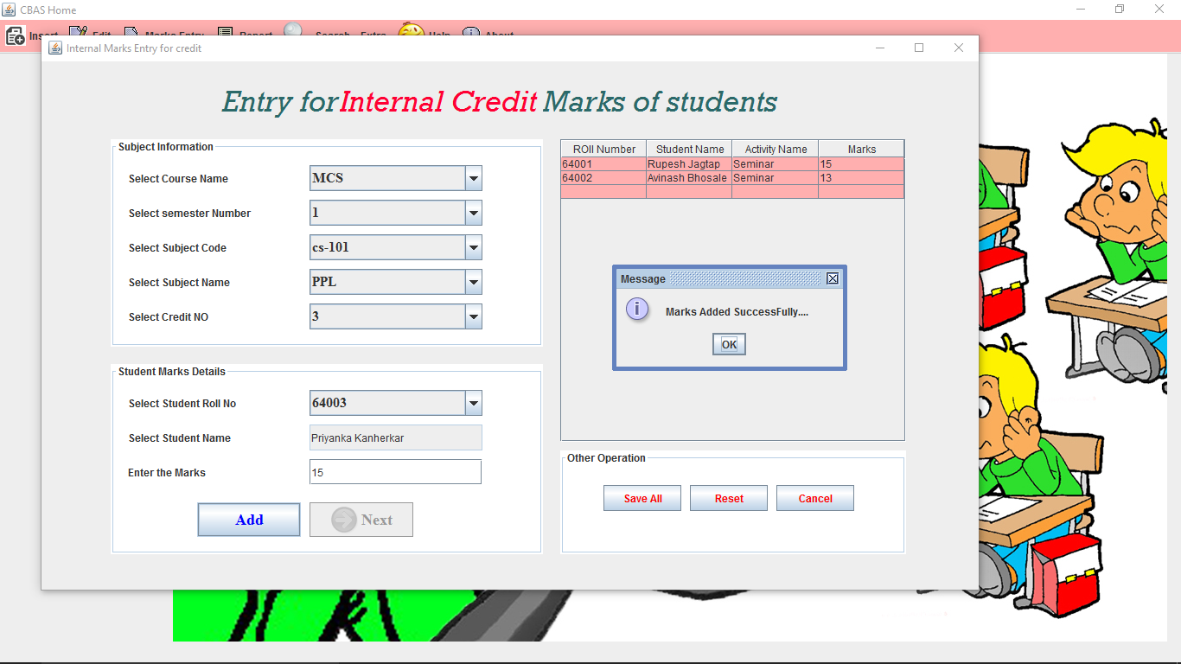

**10) Search Students**

**(by Id and Name)**

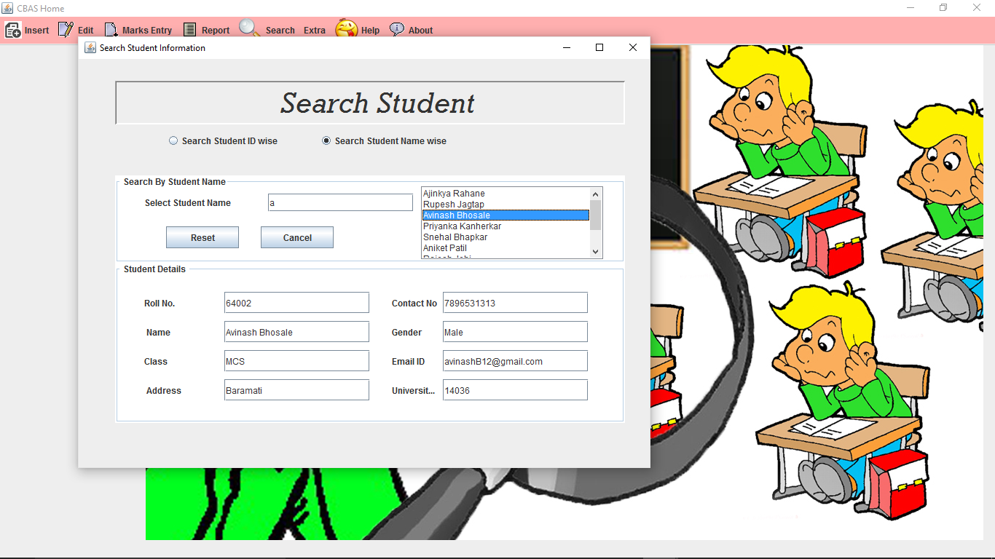

**11) View All Details of students**

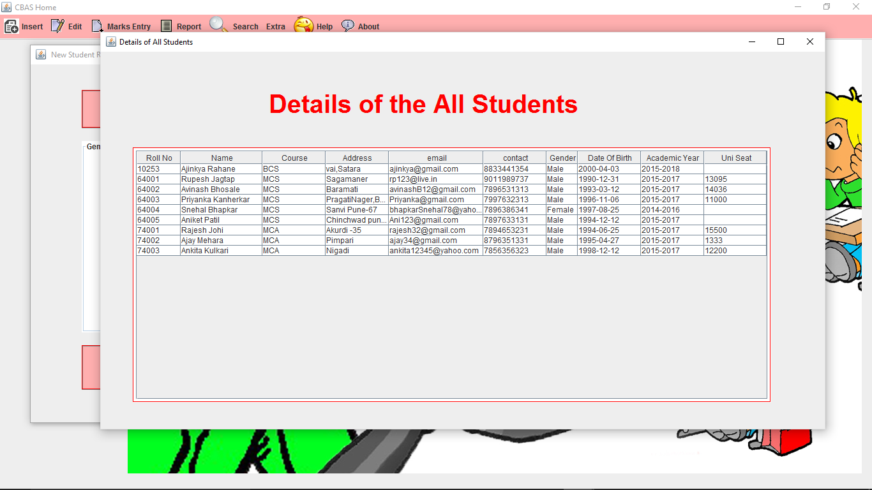

* Report of Registered Student.

**Future Enhancements**

* Generate the graph report for the student result analysis system.
* Maintain the students academic project details.
* Marks Entry for External Exam .
* To Develop the more flexible user interface.

**Conclusion**

The “Credit Based Evaluation System”, which is developed, has many advantages over manual system.

Such as:

* The System beings automated saves both the time and efforts.
* Less man power is required for same job.
* Any kind of information regarding Students, marks of students, result of students marks as per various way like rank-wise, absent-wise etc. can be obtained immediately.
* The system has a user friendly user interface.
* Various reports are generated which helps in manage “Credit based evaluation System” in details. Proper error messages helps user to enter valid data.

**Bibliography**

The manuals / books referred during the analysis and the design of “Credit Based Evaluation system” are as follows:

* *The Complete Reference Java 2: By Herbert Schildt.*
* Object Oriented Software Engineering reference book
* [*www.google.com*](http://www.google.com/)